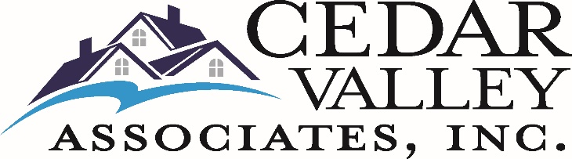
Rivers Edge No. 1
Area of 28th Ave and Fillmore St.
Jenison, MI

8879 24th Ave Jenison, MI 49428

Water Front Lots on Edgewater Lake
Lot Pricing:
Lot 1 | $165,000 |  | Lot 9 | $165,000
Lot 2 | $165,000 |  | Lot 10 | $165,000
Lot 3 | $165,000 |  | Lot 11 | $165,000
Lot 4 | $165,000 |  | Lot 12 | $165,000
Lot 5 | $165,000 |  | Lot 13 | $165,000
Lot 6 | $165,000 |  | Lot 14 | $163,000
Lot 7 | $165,000 |  | Lot 15 | $163,000
Lot 8 | $165,000 |  | Lot 16 | $157,000

*Rights reserved to change lot pricing at anytime
- 20 Acre limited motor /limit speed, spring fed lake
- Located in Jenison, Area of Fillmore and 28th Ave, Adjacent to Grand River Park and the Grand River
- Fully improved building sites – city water/sewer, sidewalks, high speed internet
- Minimum building restrictions: Ranch – 1600 sq. ft. on the main floor. Two Story - 1200 sq. ft. on the main floor.
- Jenison Schools
- Covenants and Restrictions available upon request

E-mail: denise@cedarvalleylakes.com 616-457-5220 www.cedarvalleylakes.com

